How to filter data Horizontally in Excel

Filtering data horizontally in Excel allows you to selectively display or analyze specific columns of data while hiding the others. It helps in focusing on particular attributes or variables of interest and facilitates data exploration, comparison, and decision-making based on specific criteria.

The given data represents different product categories and their corresponding attributes, such as the quantity, total sold, and unit price. Filtering data horizontally by "Hardware" allows us to focus solely on the hardware-related products, namely GPUs and Keyboards. This enables a targeted analysis and comparison of the hardware category's specific metrics, aiding in decision-making and performance evaluation. In today’s tutorial, we will learn how to filter data horizontally by taking this dataset as an example.

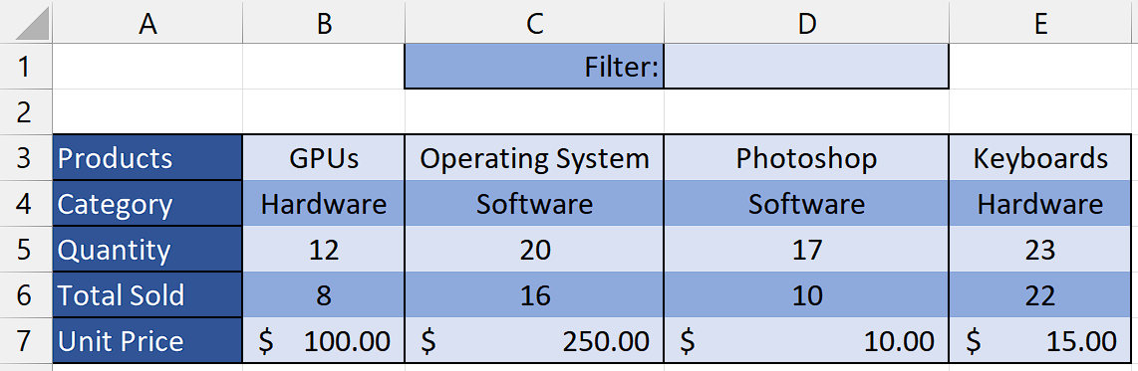

## Step 1 – Write the name of filter

* Select any empty cell and enter the name of the filter you would like to use for data filtering.
* For example, we have written “Hardware” in the cell D1.



## Step 2 – Select the cell

* Select any empty cell where you would like the horizontally filtered data to be displayed.
* In this cell, we will apply the “FILTER” Function to filter the data horizontally.



## Step 3 – Write and implement the formula

* Write the following formula in the selected cell

=FILTER(B3:E7, B4:E4=D1, “Not Found”)

**FILTER:** This is the function used to filter data in Excel. It retrieves rows or columns from a range based on specified criteria.

**B3:E7:** This is the range of data you want to filter. It represents the cells from B3 to E7.

**B4:E4=D1:** This is the filtering criteria. It specifies that you want to filter the data where the values in cells B4 to E4 are equal to the value in cell D1.

**"Not Found":** This is the optional value you want to display if the filter does not find any matching data. In this case, if no matching data is found, it will display "Not Found".

* After writing the formula, press “Enter” and your data will be filtered horizontally.



## Explanation of the Formula used in Step 3:

The given formula, =FILTER(B3:E7, B4:E4=D1, "Not Found"), filters the range of cells B3:E7 based on a condition. The condition is specified as B4:E4=D1, which checks if the values in cells B4:E4 are equal to the text "Hardware" in cell D1. The FILTER function then returns the subset of data from the range B3:E7 where the condition is true. In this case, it will return the cells where the corresponding cell in the same column as D1 contains the text "Hardware". If the condition is not met, i.e., there are no cells with the value "Hardware" in the same column as D1, it will return the text "Not Found". This formula helps in extracting specific data from a larger dataset based on a given criterion and filters the data horizontally.